ASSIGNMENT NO 1

Name: Hrutu Hemant Surve Class: TY-01 CSE

PRN: 1921321242014 Faculty: Priyanka Avhad Ma`am

_____________________________________________________________________________

AIM : Demonstrate Activity LifeCycle

XML CODE :

<?xml version="1.0" encoding="utf-8"?>  
<androidx.constraintlayout.widget.ConstraintLayout xmlns:android="http://schemas.android.com/apk/res/android"  
 xmlns:app="http://schemas.android.com/apk/res-auto"  
 xmlns:tools="http://schemas.android.com/tools"  
 android:layout_width="match_parent"  
 android:layout_height="match_parent"  
 tools:context="com.example.assignment1a.MainActivity">  
  
 <TextView  
 android:layout_width="118dp"  
 android:layout_height="63dp"  
 android:fontFamily="sans-serif-black"  
 android:text="Activity Life Cyc;le"  
 android:textStyle="bold"  
 app:layout_constraintBottom_toBottomOf="parent"  
 app:layout_constraintLeft_toLeftOf="parent"  
 app:layout_constraintRight_toRightOf="parent"  
 app:layout_constraintTop_toTopOf="parent" />  
</androidx.constraintlayout.widget.ConstraintLayout>

XML OUTPUT :

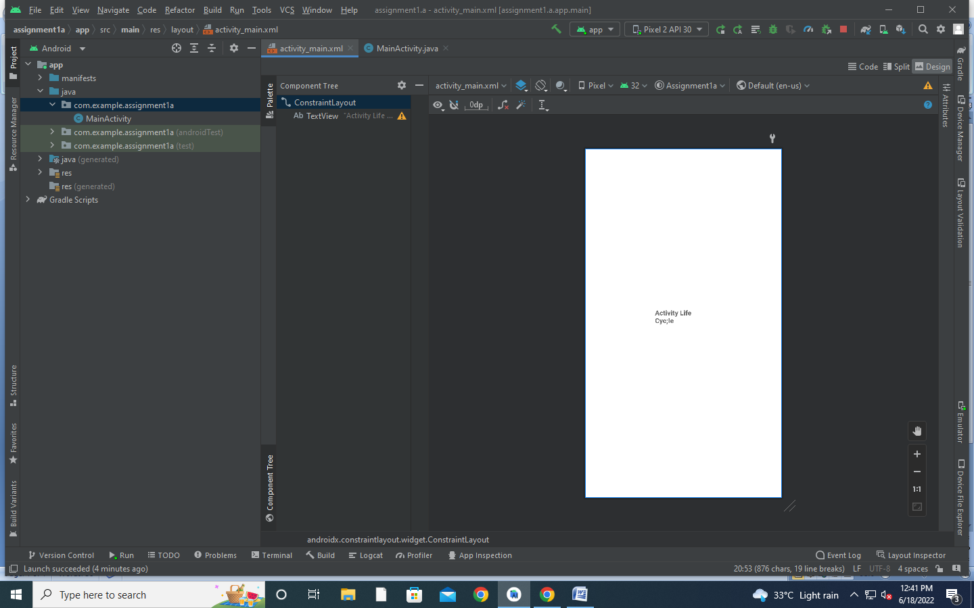

JAVA CODE :

package com.example.assignment1a;  
  
import android.app.Activity;  
import android.os.Bundle;  
import android.util.Log;  
  
public class MainActivity extends Activity {  
  
 @Override  
 protected void onCreate(Bundle savedInstanceState) {  
 super.onCreate(savedInstanceState);  
 setContentView(R.layout.*activity_main*);  
 Log.*d*("lifecycle","onCreate invoked");  
 }  
 @Override  
 protected void onStart() {  
 super.onStart();  
 Log.*d*("lifecycle","onStart invoked");  
 }  
 @Override  
 protected void onResume() {  
 super.onResume();  
 Log.*d*("lifecycle","onResume invoked");  
 }  
 @Override  
 protected void onPause() {  
 super.onPause();  
 Log.*d*("lifecycle","onPause invoked");  
 }  
 @Override  
 protected void onStop() {  
 super.onStop();  
 Log.*d*("lifecycle","onStop invoked");  
 }  
 @Override  
 protected void onRestart() {  
 super.onRestart();  
 Log.*d*("lifecycle","onRestart invoked");  
 }  
 @Override  
 protected void onDestroy() {  
 super.onDestroy();  
 Log.*d*("lifecycle","onDestroy invoked");  
 }  
}

OUTPUT :

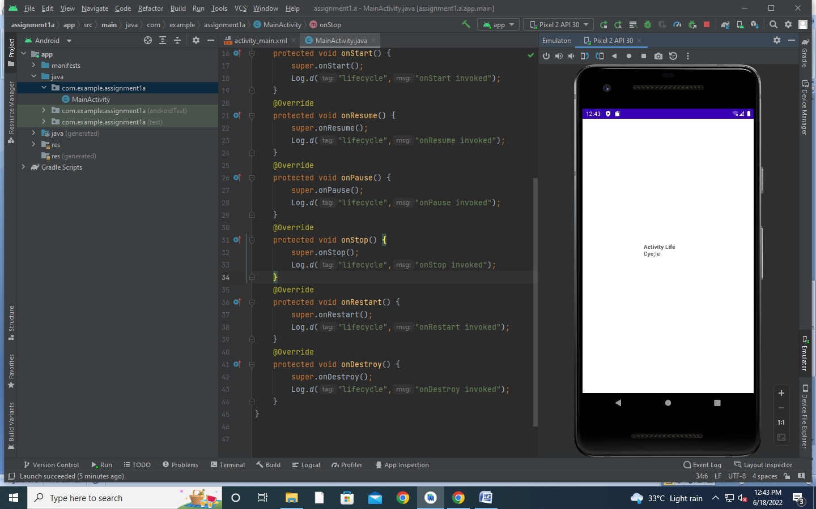



****************************End of the Assignment****************************

ASSIGNMENT NO 2

Name: Hrutu Hemant Surve Class: TY-01 CSE

PRN: 1921321242014 Faculty: Priyanka Avhad Ma`am

_____________________________________________________________________________

AIM : Explain Arthimetic Operation using Table Layout

XML CODE :

<?xml version="1.0" encoding="utf-8"?>  
<androidx.constraintlayout.widget.ConstraintLayout xmlns:android="http://schemas.android.com/apk/res/android"  
 xmlns:app="http://schemas.android.com/apk/res-auto"  
 xmlns:tools="http://schemas.android.com/tools"  
 android:layout_width="match_parent"  
 android:layout_height="match_parent"  
 tools:context=".MainActivity">  
  
 <EditText  
 android:id="@+id/et1"  
 android:layout_width="wrap_content"  
 android:layout_height="wrap_content"  
 android:layout_marginBottom="76dp"  
 android:ems="10"  
 android:hint="enter first number"  
 android:inputType="textPersonName"  
 android:minHeight="48dp"  
 app:layout_constraintBottom_toTopOf="@+id/et2"  
 app:layout_constraintEnd_toEndOf="parent"  
 app:layout_constraintStart_toStartOf="parent" />  
  
 <EditText  
 android:id="@+id/et2"  
 android:layout_width="wrap_content"  
 android:layout_height="wrap_content"  
 android:layout_marginTop="321dp"  
 android:ems="10"  
 android:hint="enter second number"  
 android:inputType="textPersonName"  
 android:minHeight="48dp"  
 app:layout_constraintEnd_toEndOf="parent"  
 app:layout_constraintStart_toStartOf="parent"  
 app:layout_constraintTop_toTopOf="parent" />  
  
 <Button  
 android:id="@+id/btnadd"  
 android:layout_width="wrap_content"  
 android:layout_height="wrap_content"  
 android:layout_marginStart="51dp"  
 android:layout_marginTop="42dp"  
 android:text="+"  
 app:layout_constraintStart_toStartOf="@+id/et2"  
 app:layout_constraintTop_toBottomOf="@+id/et2" />  
  
 <TextView  
 android:id="@+id/tvans"  
 android:layout_width="wrap_content"  
 android:layout_height="wrap_content"  
 android:layout_marginStart="160dp"  
 android:layout_marginTop="88dp"  
 android:text="answer"  
 app:layout_constraintStart_toStartOf="parent"  
 app:layout_constraintTop_toTopOf="parent" />  
  
 <Button  
 android:id="@+id/btnsub"  
 android:layout_width="wrap_content"  
 android:layout_height="wrap_content"  
 android:layout_marginStart="2dp"  
 android:layout_marginBottom="7dp"  
 android:text="-"  
 app:layout_constraintBottom_toTopOf="@+id/btnmultiply"  
 app:layout_constraintStart_toStartOf="@+id/btnmultiply" />  
  
 <Button  
 android:id="@+id/btnmultiply"  
 android:layout_width="wrap_content"  
 android:layout_height="wrap_content"  
 android:layout_marginEnd="1dp"  
 android:text="*"  
 app:layout_constraintBottom_toTopOf="@+id/btndiv"  
 app:layout_constraintEnd_toEndOf="@+id/btndiv" />  
 <Button  
 android:id="@+id/btndiv"  
 android:layout_width="wrap_content"  
 android:layout_height="wrap_content"  
 android:layout_marginStart="149dp"  
 android:layout_marginTop="112dp"  
 android:layout_marginBottom="112dp"  
 android:text="/"  
 app:layout_constraintBottom_toBottomOf="parent"  
 app:layout_constraintStart_toStartOf="parent"  
 app:layout_constraintTop_toBottomOf="@+id/btnadd" />  
  
</androidx.constraintlayout.widget.ConstraintLayout>

XML OUTPUT :

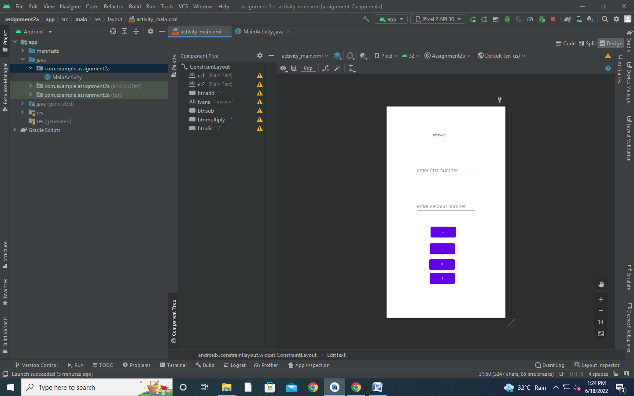

JAVA CODE :

package com.example.assignment2a;  
  
import androidx.appcompat.app.AppCompatActivity;  
  
import android.os.Bundle;  
import android.view.Gravity;  
import android.view.View;  
import android.widget.Button;  
import android.widget.EditText;  
import android.widget.TextView;  
import android.widget.Toast;  
  
public class MainActivity extends AppCompatActivity {  
 EditText e1, e2;  
 TextView t1;  
 Button badd;  
 Button bsub;  
 Button bmultiply;  
 Button bdiv;  
 int a, b, c;  
  
 @Override  
 protected void onCreate(Bundle savedInstanceState) {  
 super.onCreate(savedInstanceState);  
 setContentView(R.layout.*activity_main*);  
 e1 = findViewById(R.id.*et1*);  
 e2 = findViewById(R.id.*et2*);  
 t1 = findViewById(R.id.*tvans*);  
 badd = findViewById(R.id.*btnadd*);  
 bsub = findViewById(R.id.*btnsub*);

bmultiply= findViewById(R.id.*btnmultiply*);  
 bdiv= findViewById(R.id.*btndiv*);  
 badd.setOnClickListener(new View.OnClickListener() {  
 @Override  
 public void onClick(View view) {  
 a = Integer.*parseInt*(e1.getText().toString());  
 b = Integer.*parseInt*(e2.getText().toString());  
 c = a + b;  
 t1.setText("" + c);  
 Toast t=Toast.*makeText*(MainActivity.this,"Addition="+c,Toast.*LENGTH_SHORT*);  
 t.setGravity(Gravity.*CENTER*,0,0);  
 t.show();  
 }  
 });  
 bsub.setOnClickListener(new View.OnClickListener() {  
 @Override  
 public void onClick(View view) {  
 a = Integer.*parseInt*(e1.getText().toString());  
 b = Integer.*parseInt*(e2.getText().toString());  
 c = a - b;  
 t1.setText("" + c);  
 }  
 });  
  
 bmultiply.setOnClickListener(new View.OnClickListener() {  
 @Override  
 public void onClick(View view) {  
 a = Integer.*parseInt*(e1.getText().toString());  
 b = Integer.*parseInt*(e2.getText().toString());  
 c = a * b;  
 t1.setText("" + c);  
 }  
 });  
 bmultiply.setOnClickListener(new View.OnClickListener() {  
 @Override  
 public void onClick(View view) {  
 a = Integer.*parseInt*(e1.getText().toString());  
 b = Integer.*parseInt*(e2.getText().toString());  
 c = a * b;  
 t1.setText("" + c);  
 }  
 });  
 bdiv.setOnClickListener(new View.OnClickListener() {  
 @Override  
 public void onClick(View view) {  
 a = Integer.*parseInt*(e1.getText().toString());  
 b = Integer.*parseInt*(e2.getText().toString());  
 c = a / b;  
 t1.setText("" + c);  
 }  
 });  
 }  
}

OUTPUT :

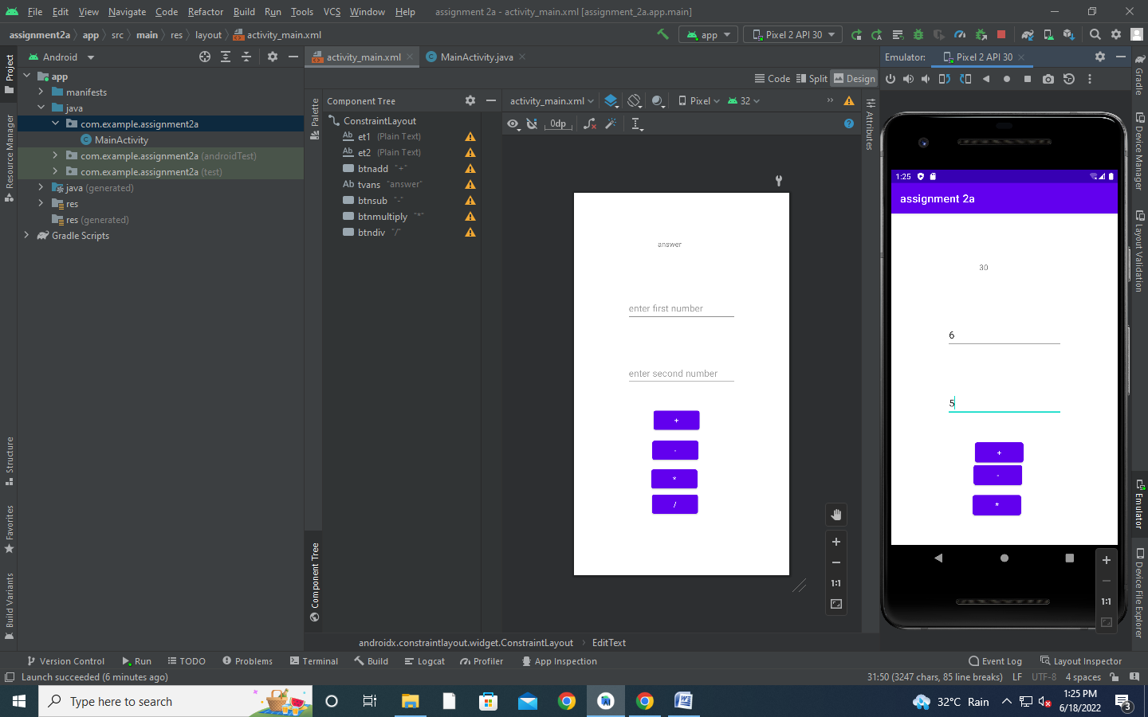

*****************************End of the Assignment***************************

ASSIGNMENT NO 3

Name: Hrutu Hemant Surve Class: TY-01 CSE

PRN: 1921321242014 Faculty: Priyanka Avhad Ma`am

_____________________________________________________________________________

AIM : Implementation of getText() and setText() Methods

XML CODE :

<?xml version="1.0" encoding="utf-8"?>  
<RelativeLayout xmlns:android="http://schemas.android.com/apk/res/android"  
 xmlns:app="http://schemas.android.com/apk/res-auto"  
 xmlns:tools="http://schemas.android.com/tools"  
 android:layout_width="match_parent"  
 android:layout_height="match_parent"  
 android:background="#FFFF8D"  
 tools:context="com.example.assignment3a.MainActivity">  
  
 <TextView  
 android:id="@+id/textView"  
 android:layout_width="wrap_content"  
 android:layout_height="wrap_content"  
 android:layout_alignParentLeft="true"  
 android:layout_alignParentStart="true"  
 android:layout_alignParentTop="true"  
 android:text="NAME"  
 android:textSize="20sp"  
 android:layout_margin="20dp" />  
  
 <TextView  
 android:id="@+id/textView2"  
 android:layout_width="wrap_content"  
 android:layout_height="wrap_content"  
 android:textSize="20sp"  
 android:text="CLASS"  
 android:layout_marginTop="38dp"  
 android:layout_below="@+id/textView"  
 android:layout_alignLeft="@+id/textView"  
 android:layout_alignStart="@+id/textView" />  
  
 <EditText  
 android:id="@+id/editName"  
 android:layout_width="wrap_content"  
 android:layout_height="wrap_content"  
 android:ems="10"  
 android:inputType="textPersonName"  
 android:hint="Enter Name"  
 android:layout_alignParentTop="true"  
 android:layout_alignParentRight="true"  
 android:layout_alignParentEnd="true"  
 android:layout_alignLeft="@+id/editClass"  
 android:layout_alignStart="@+id/editClass" />

<EditText  
 android:id="@+id/editClass"  
 android:layout_width="wrap_content"  
 android:layout_height="wrap_content"  
 android:ems="10"  
 android:hint="Enter Class"  
 android:inputType="textPassword"  
 android:layout_alignBottom="@+id/textView2"  
 android:layout_alignParentRight="true"  
 android:layout_alignParentEnd="true"  
 android:layout_marginRight="18dp"  
 android:layout_marginEnd="18dp" />  
  
 <Button  
 android:id="@+id/buttonSubmit"  
 android:layout_width="wrap_content"  
 android:layout_height="wrap_content"  
 android:layout_alignParentLeft="true"  
 android:layout_alignParentStart="true"  
 android:layout_below="@+id/textView2"  
 android:layout_marginTop="20dp"  
 android:text="SUBMIT" />  
  
 <Button  
 android:id="@+id/buttonReset"  
 android:layout_width="wrap_content"  
 android:layout_height="wrap_content"  
 android:text="RESET"  
 android:layout_alignBaseline="@+id/buttonSubmit"  
 android:layout_alignBottom="@+id/buttonSubmit"  
 android:layout_centerHorizontal="true" />  
  
 <TextView  
 android:id="@+id/tvResult"  
 android:layout_width="wrap_content"  
 android:layout_height="wrap_content"  
 android:layout_alignParentBottom="true"  
 android:layout_alignParentLeft="true"  
 android:layout_alignParentStart="true"  
 android:layout_marginBottom="143dp"  
 android:textSize="30sp" />  
  
</RelativeLayout>

XML OUTPUT :

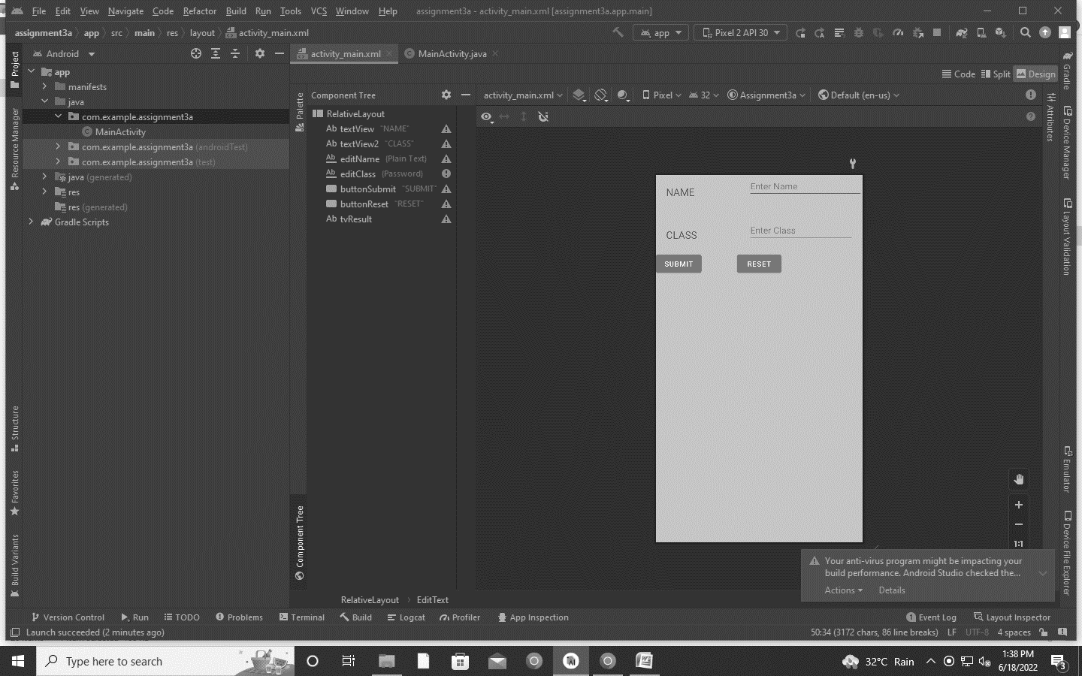

JAVA CODE :

package com.example.assignment3a;  
  
import android.os.Bundle;  
import android.view.View;  
import android.widget.Button;  
import android.widget.EditText;  
import android.widget.TextView;  
  
import androidx.appcompat.app.AppCompatActivity;  
  
public class MainActivity extends AppCompatActivity {  
 // These are the global variables  
 EditText editName, editPassword;  
 TextView result;  
 Button buttonSubmit, buttonReset;  
  
 @Override  
 protected void onCreate(Bundle savedInstanceState) {  
 super.onCreate(savedInstanceState);  
 setContentView(R.layout.*activity_main*);  
  
 editName = (EditText) findViewById(R.id.*editName*);  
 editPassword = (EditText) findViewById(R.id.*editClass*);  
 result = (TextView) findViewById(R.id.*tvResult*);  
 buttonSubmit = (Button) findViewById(R.id.*buttonSubmit*);  
 buttonReset = (Button) findViewById(R.id.*buttonReset*);  
 /*  
 Submit Button  
 */  
 buttonSubmit.setOnClickListener(new View.OnClickListener() {  
  
 @Override  
 public void onClick(View v) {  
 String name = editName.getText().toString();  
 String password = editPassword.getText().toString();  
 result.setText("Name:\t" + name + "\nClass:\t" + password);  
  
 }  
 });  
  
 /*  
 Reset Button  
 */  
 buttonReset.setOnClickListener(new View.OnClickListener() {  
 @Override  
 public void onClick(View v) {  
 editName.setText("");  
 editPassword.setText("");  
 result.setText("");  
 editName.requestFocus();  
 }  
 });  
 }  
}\

******************************End of the Assignment**************************

ASSIGNMENT NO 4

Name: Hrutu Hemant Surve Class: TY-01 CSE

PRN: 1921321242014 Faculty: Priyanka Avhad Ma`am

_____________________________________________________________________________

AIM : Implementation of getExtra() and putExtra() Method on Intent

XML CODE :

<?xml version="1.0" encoding="utf-8"?>  
<androidx.constraintlayout.widget.ConstraintLayout xmlns:android="http://schemas.android.com/apk/res/android"  
 xmlns:app="http://schemas.android.com/apk/res-auto"  
 xmlns:tools="http://schemas.android.com/tools"  
 android:layout_width="match_parent"  
 android:layout_height="match_parent"  
 tools:context="com.example.assignment4a.MainActivity">  
  
 <TextView  
 android:layout_width="wrap_content"  
 android:layout_height="wrap_content"  
 android:layout_marginEnd="8dp"  
 android:layout_marginStart="8dp"  
 android:layout_marginTop="8dp"  
 android:text="Main Activity"  
 app:layout_constraintBottom_toBottomOf="parent"  
 app:layout_constraintEnd_toEndOf="parent"  
 app:layout_constraintHorizontal_bias="0.454"  
 app:layout_constraintLeft_toLeftOf="parent"  
 app:layout_constraintRight_toRightOf="parent"  
 app:layout_constraintStart_toStartOf="parent"  
 app:layout_constraintTop_toTopOf="parent"  
 app:layout_constraintVertical_bias="0.06"  
 tools:ignore="HardcodedText" />  
  
 <Button  
 android:id="@+id/button"  
 android:layout_width="wrap_content"  
 android:layout_height="wrap_content"  
 android:layout_marginEnd="8dp"  
 android:layout_marginStart="8dp"  
 android:layout_marginTop="392dp"  
 android:onClick="callSecondActivity"  
 android:text="Call second activity"  
 app:layout_constraintEnd_toEndOf="parent"  
 app:layout_constraintStart_toStartOf="parent"  
 app:layout_constraintTop_toTopOf="parent"  
 tools:ignore="HardcodedText,UsingOnClickInXml" />  
  
</androidx.constraintlayout.widget.ConstraintLayout>

<?xml version="1.0" encoding="utf-8"?>  
<androidx.constraintlayout.widget.ConstraintLayout xmlns:android="http://schemas.android.com/apk/res/android"  
 xmlns:app="http://schemas.android.com/apk/res-auto"  
 xmlns:tools="http://schemas.android.com/tools"  
 android:layout_width="match_parent"  
 android:layout_height="match_parent"  
 tools:context="com.example.assignment4a.MainActivity2"  
 tools:ignore="MissingClass">  
  
 <TextView  
 android:layout_width="141dp"  
 android:layout_height="216dp"  
 android:layout_marginStart="8dp"  
 android:layout_marginTop="8dp"  
 android:layout_marginEnd="8dp"  
 android:text="Second Activity"  
 app:layout_constraintBottom_toBottomOf="parent"  
 app:layout_constraintEnd_toEndOf="parent"  
 app:layout_constraintHorizontal_bias="0.454"  
 app:layout_constraintLeft_toLeftOf="parent"  
 app:layout_constraintRight_toRightOf="parent"  
 app:layout_constraintStart_toStartOf="parent"  
 app:layout_constraintTop_toTopOf="parent"  
 app:layout_constraintVertical_bias="0.06"  
 tools:ignore="HardcodedText" />  
  
 <Button  
 android:id="@+id/button"  
 android:layout_width="wrap_content"  
 android:layout_height="wrap_content"  
 android:layout_marginEnd="8dp"  
 android:layout_marginStart="8dp"  
 android:layout_marginTop="392dp"  
 android:onClick="callFirstActivity"  
 android:text="Call first activity"  
 app:layout_constraintEnd_toEndOf="parent"  
 app:layout_constraintStart_toStartOf="parent"  
 app:layout_constraintTop_toTopOf="parent"  
 tools:ignore="HardcodedText,UsingOnClickInXml" />  
</androidx.constraintlayout.widget.ConstraintLayout>

XML OUTPUT :

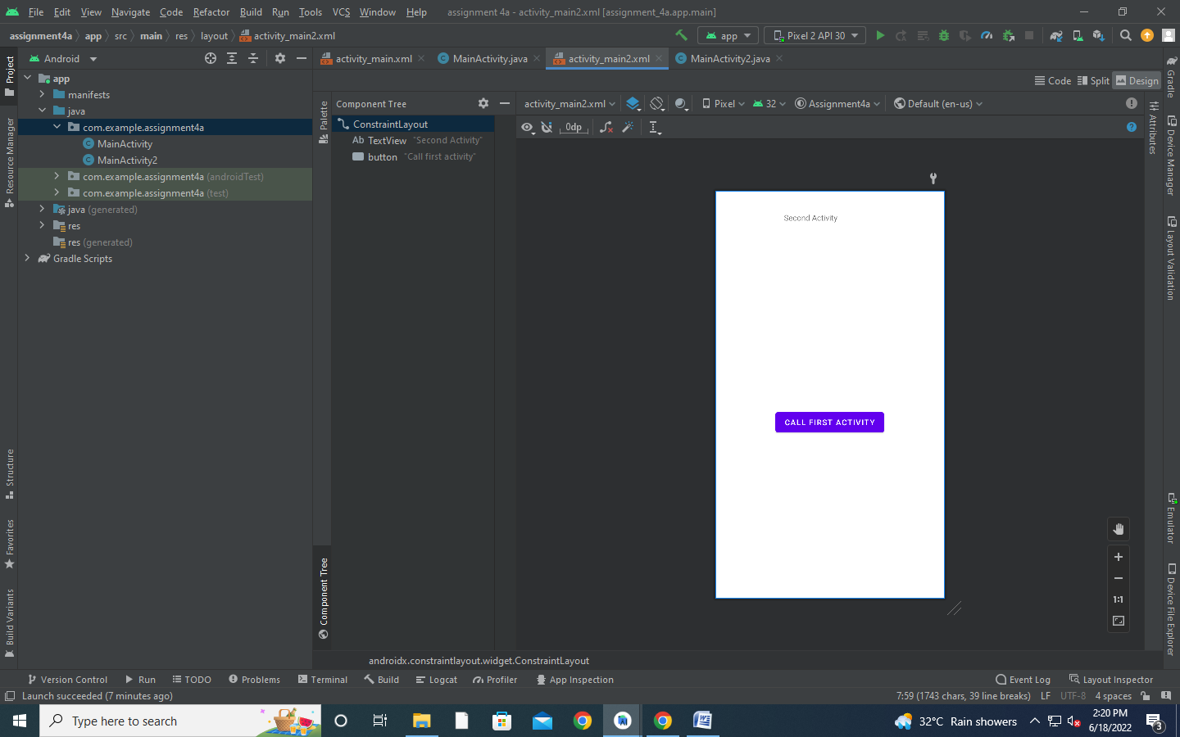

JAVA CODE :

package com.example.assignment4a;  
  
import android.content.Intent;  
import android.os.Bundle;  
import android.view.View;  
  
import androidx.appcompat.app.AppCompatActivity;  
  
public class MainActivity extends AppCompatActivity {  
  
 @Override  
 protected void onCreate(Bundle savedInstanceState) {  
 super.onCreate(savedInstanceState);  
 setContentView(R.layout.*activity_main*);  
 }  
 public void callSecondActivity(View view){  
 Intent i = new Intent(getApplicationContext(), MainActivity2.class);  
 i.putExtra("Value1", "Android By Javatpoint");  
 i.putExtra("Value2", "Simple Tutorial");  
 // Set the request code to any code you like, you can identify the  
 // callback via this code  
 startActivity(i);  
 }  
  
}

package com.example.assignment4a;  
  
import android.content.Intent;  
  
import android.os.Bundle;  
import android.view.View;  
import android.widget.Toast;  
  
import androidx.appcompat.app.AppCompatActivity;  
  
public class MainActivity2 extends AppCompatActivity {  
  
 @Override  
 protected void onCreate(Bundle savedInstanceState) {  
 super.onCreate(savedInstanceState);  
 setContentView(R.layout.*activity_main2*);  
 Bundle extras = getIntent().getExtras();  
 String value1 = extras.getString("Value1");  
 String value2 = extras.getString("Value2");  
 Toast.*makeText*(getApplicationContext(),"Values are:\n First value: "+value1+  
 "\n Second Value: "+value2, Toast.*LENGTH_LONG*).show();  
 }  
 public void callFirstActivity(View view){  
 Intent i = new Intent(getApplicationContext(), MainActivity.class);  
 startActivity(i);  
 }  
  
}

OUTPUT :

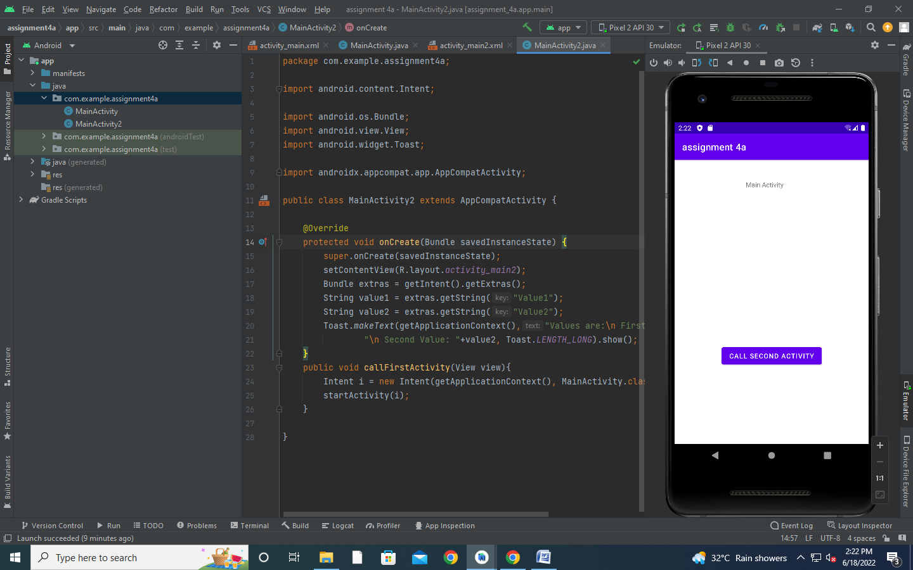

********************************End of the Assignment************************

ASSIGNMENT NO 5

Name: Hrutu Hemant Surve Class: TY-01 CSE

PRN: 1921321242014 Faculty: Priyanka Avhad Ma`am

_____________________________________________________________________________

AIM : Create android application to implement on click event

XML CODE OF ACTIVITY MAIN :

<?xml version="1.0" encoding="utf-8"?>  
<androidx.constraintlayout.widget.ConstraintLayout xmlns:android="http://schemas.android.com/apk/res/android"  
 xmlns:app="http://schemas.android.com/apk/res-auto"  
 xmlns:tools="http://schemas.android.com/tools"  
 android:layout_width="match_parent"  
 android:layout_height="match_parent"  
 tools:context=".MainActivity">  
  
 <Button  
 android:id="@+id/button"  
 android:layout_width="wrap_content"  
 android:layout_height="wrap_content"  
 android:text="Frame2"  
 app:layout_constraintBottom_toBottomOf="parent"  
 app:layout_constraintEnd_toEndOf="parent"  
 app:layout_constraintHorizontal_bias="0.362"  
 app:layout_constraintStart_toStartOf="parent"  
 app:layout_constraintTop_toTopOf="parent"  
 app:layout_constraintVertical_bias="0.209" />  
  
 <Button  
 android:id="@+id/button2"  
 android:layout_width="wrap_content"  
 android:layout_height="wrap_content"  
 android:text="Phone Number"  
 app:layout_constraintBottom_toBottomOf="parent"  
 app:layout_constraintEnd_toEndOf="parent"  
 app:layout_constraintHorizontal_bias="0.447"  
 app:layout_constraintStart_toStartOf="parent"  
 app:layout_constraintTop_toTopOf="parent"  
 app:layout_constraintVertical_bias="0.327" />  
  
 <Button  
 android:id="@+id/button3"  
 android:layout_width="wrap_content"  
 android:layout_height="wrap_content"  
 android:text="Website"  
 app:layout_constraintBottom_toBottomOf="parent"  
 app:layout_constraintEnd_toEndOf="parent"  
 app:layout_constraintHorizontal_bias="0.362"  
 app:layout_constraintStart_toStartOf="parent"  
 app:layout_constraintTop_toTopOf="parent"  
 app:layout_constraintVertical_bias="0.426" />  
  
 <Button  
 android:id="@+id/button4"  
 android:layout_width="wrap_content"  
 android:layout_height="wrap_content"  
 android:text="LongClick"  
 app:layout_constraintBottom_toBottomOf="parent"  
 app:layout_constraintEnd_toEndOf="parent"  
 app:layout_constraintHorizontal_bias="0.356"  
 app:layout_constraintStart_toStartOf="parent"  
 app:layout_constraintTop_toTopOf="parent"  
 app:layout_constraintVertical_bias="0.516" />  
  
 <Button  
 android:id="@+id/button6"  
 android:layout_width="wrap_content"  
 android:layout_height="wrap_content"  
 android:text="Google map"  
 app:layout_constraintBottom_toBottomOf="parent"  
 app:layout_constraintEnd_toEndOf="parent"  
 app:layout_constraintHorizontal_bias="0.356"  
 app:layout_constraintStart_toStartOf="parent"  
 app:layout_constraintTop_toTopOf="parent"  
 app:layout_constraintVertical_bias="0.623" />  
</androidx.constraintlayout.widget.ConstraintLayout>

XML OUTPUT OF ACTIVITY MAIN :

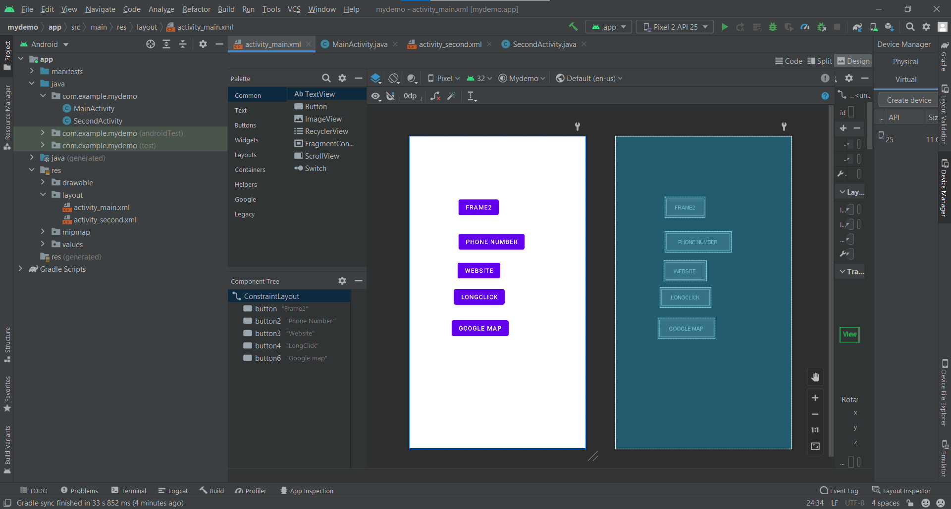

XML CODE OF ACTIVITY SECOND :

<?xml version="1.0" encoding="utf-8"?>  
<androidx.constraintlayout.widget.ConstraintLayout xmlns:android="http://schemas.android.com/apk/res/android"  
 xmlns:app="http://schemas.android.com/apk/res-auto"  
 xmlns:tools="http://schemas.android.com/tools"  
 android:layout_width="match_parent"  
 android:layout_height="match_parent"  
 tools:context=".SecondActivity">  
  
 <Button  
 android:id="@+id/button5"  
 android:layout_width="223dp"  
 android:layout_height="70dp"  
 android:text="Back To First Page"  
 app:layout_constraintBottom_toBottomOf="parent"  
 app:layout_constraintEnd_toEndOf="parent"  
 app:layout_constraintStart_toStartOf="parent"  
 app:layout_constraintTop_toTopOf="parent" />  
</androidx.constraintlayout.widget.ConstraintLayout>

XML OUTPUT OF ACTIVITY SECOND :

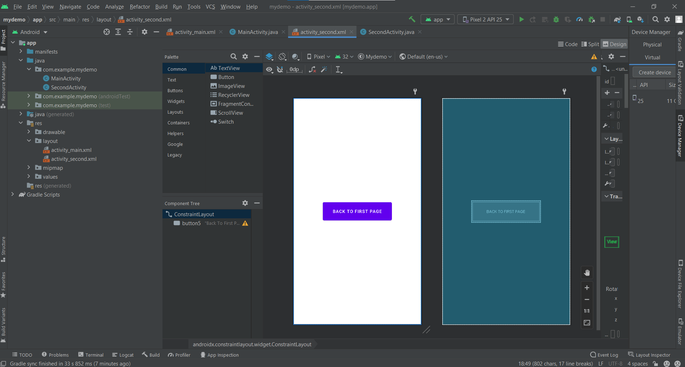

JAVA CODE OF ACTIVITY MAIN :

package com.example.mydemo;  
  
import androidx.appcompat.app.AppCompatActivity;  
  
import android.content.Intent;  
import android.net.Uri;  
import android.os.Bundle;  
import android.view.View;  
import android.widget.Button;  
import android.widget.EditText;  
  
public class MainActivity extends AppCompatActivity {  
 Button b1,b2,b3,b4,b6;  
  
 @Override  
 protected void onCreate(Bundle savedInstanceState) {  
 super.onCreate(savedInstanceState);  
 setContentView(R.layout.*activity_main*);  
 b1=(Button)findViewById(R.id.*button*);  
 b1.setOnClickListener(new View.OnClickListener() {  
 @Override  
 public void onClick(View view) {  
 Intent i =new Intent(MainActivity.this,SecondActivity.class);  
 startActivity(i);  
  
 }  
 });  
 b2=(Button)findViewById(R.id.*button2*);  
 b2.setOnClickListener(new View.OnClickListener() {  
 @Override  
 public void onClick(View view) {  
 Intent i1=new Intent();  
 i1.setData(Uri.*parse*("tel:7387775050"));  
 i1.setAction(Intent.*ACTION_DIAL*);  
 startActivity(i1);  
 }  
 });  
 b3=(Button)findViewById(R.id.*button3*);  
 b3.setOnClickListener(new View.OnClickListener() {  
 @Override  
 public void onClick(View view) {  
 Intent i2 =new Intent();  
 i2.setData(Uri.*parse*("https://www.google.com"));  
 i2.setAction(Intent.*ACTION_VIEW*);  
 startActivity(i2);  
 }  
 });  
 b4=(Button)findViewById(R.id.*button4*);  
 b4.setOnLongClickListener(new View.OnLongClickListener() {  
 @Override  
 public boolean onLongClick(View view) {  
 Intent i3=new Intent();  
 i3.setData(Uri.*parse*("tel:7387775050"));  
 i3.setAction(Intent.*ACTION_VIEW*);  
 startActivity(i3);  
 return false;  
 }  
 });  
 b6=(Button)findViewById(R.id.*button6*);  
 b6.setOnClickListener(new View.OnClickListener() {  
 @Override  
 public void onClick(View view) {  
 Intent i = new Intent(Intent.*ACTION_VIEW*);  
 i.setData(Uri.*parse*("geo:19.8798042,75.3478223"));  
 startActivity(i);  
 }  
 });  
  
  
 }  
}

JAVA CODE OF ACTIVITY SECOND :

package com.example.mydemo;  
  
import androidx.appcompat.app.AppCompatActivity;  
  
import android.content.Intent;  
import android.os.Bundle;  
import android.view.View;  
import android.widget.Button;  
  
public class SecondActivity extends AppCompatActivity {  
 Button b5;  
 @Override  
 protected void onCreate(Bundle savedInstanceState) {  
 super.onCreate(savedInstanceState);  
 setContentView(R.layout.*activity_second*);  
 b5=(Button)findViewById(R.id.*button5*);  
 b5.setOnClickListener(new View.OnClickListener() {  
 @Override  
 public void onClick(View view) {  
 Intent i4=new Intent(SecondActivity.this,MainActivity.class);  
 startActivity(i4);  
  
 }  
 });  
 }  
}

OUTPUT :

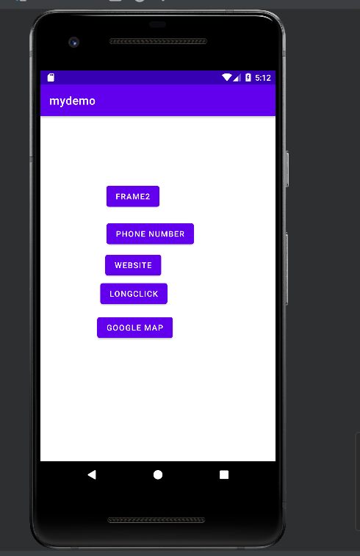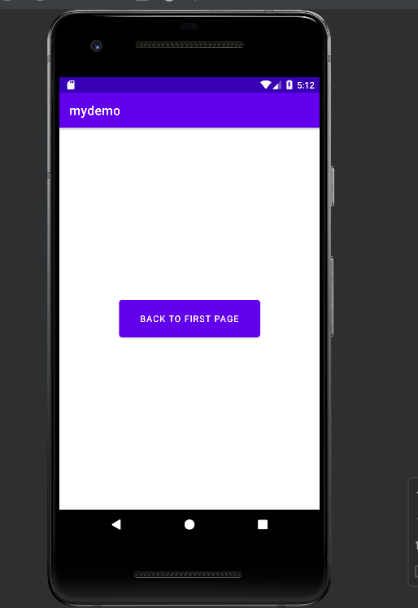

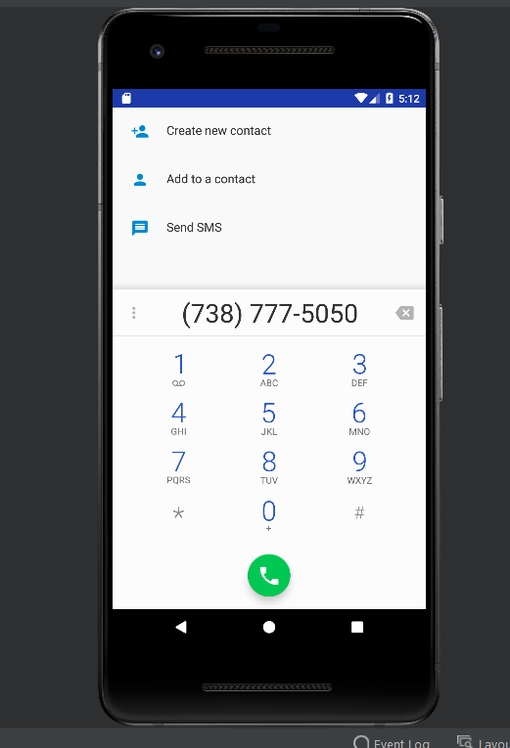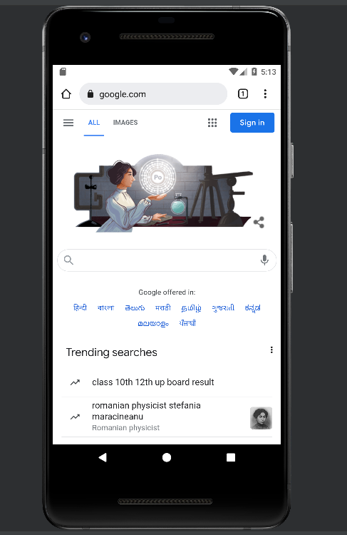

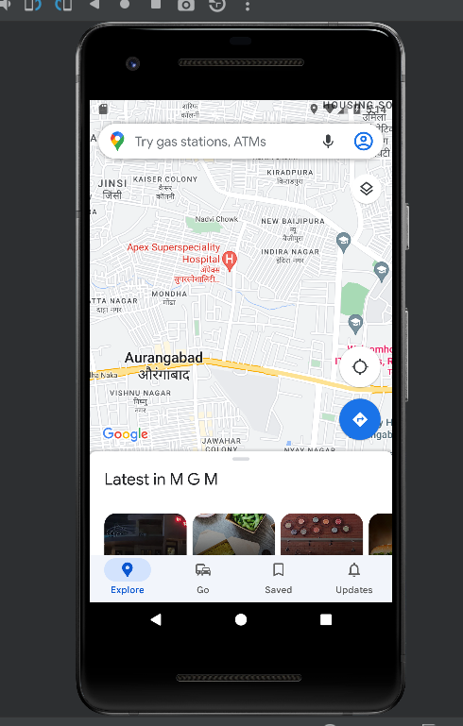

ASSIGNMENT NO 6

Name: Hrutu Hemant Surve Class: TY-01 CSE

PRN: 1921321242014 Faculty: Priyanka Avhad Ma`am

_____________________________________________________________________________

AIM : Create an android application using relative layout.

XML CODE :

<?xml version="1.0" encoding="utf-8"?>  
  
<RelativeLayout  
 android:layout_width="fill_parent"  
 android:layout_height="fill_parent"  
 xmlns:android="http://schemas.android.com/apk/res/android">  
  
 <Button  
 android:id="@+id/button1"  
 android:layout_width="wrap_content"  
 android:layout_height="wrap_content"  
 android:text="Top Left Button"  
 android:layout_alignParentLeft="true"  
 android:layout_alignParentTop="true"/>  
 <Button  
 android:id="@+id/button2"  
 android:layout_width="wrap_content"  
 android:layout_height="wrap_content"  
 android:text="Top Right Button"  
 android:layout_alignParentTop="true"  
 android:layout_alignParentRight="true"/>  
 <Button  
 android:id="@+id/button3"  
 android:layout_width="wrap_content"  
 android:layout_height="wrap_content"  
 android:text="Bottom Left Button"  
 android:layout_alignParentLeft="true"  
 android:layout_alignParentBottom="true"/>  
 <Button  
 android:id="@+id/button4"  
 android:layout_width="wrap_content"  
 android:layout_height="wrap_content"  
 android:text="Bottom Right Button"  
 android:layout_alignParentRight="true"  
 android:layout_alignParentBottom="true"/>  
 <Button  
 android:id="@+id/button5"  
 android:layout_width="fill_parent"  
 android:layout_height="wrap_content"  
 android:text="Middle Button"  
 android:layout_centerVertical="true"  
 android:layout_centerHorizontal="true"/>  
  
</RelativeLayout>

XML OUTPUT :

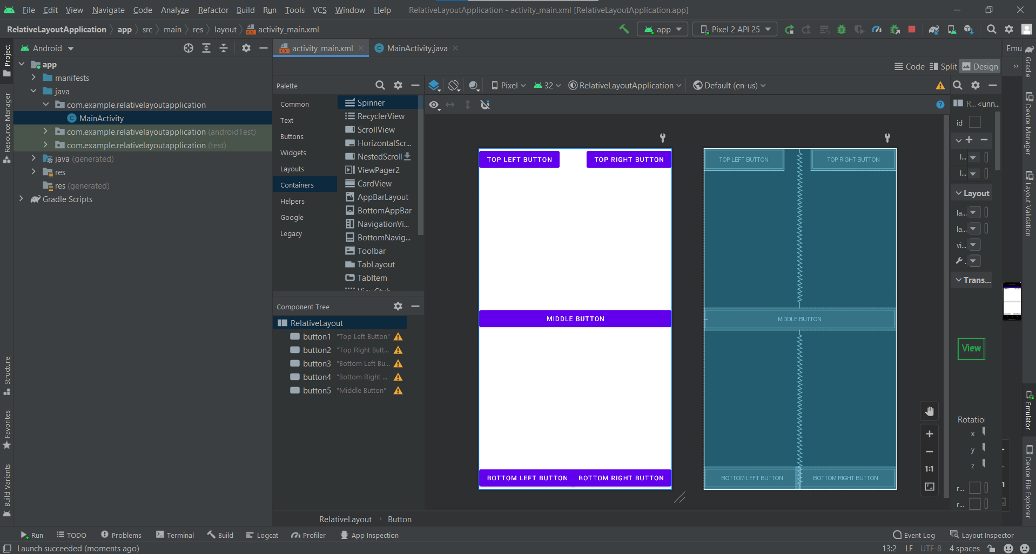

JAVA CODE :

package com.example.relativelayoutapplication;  
  
import android.os.Bundle;  
import android.app.Activity;  
  
public class MainActivity extends Activity {  
 @Override  
 protected void onCreate(Bundle savedInstanceState) {  
 super.onCreate(savedInstanceState);  
 setContentView(R.layout.*activity_main*);  
 }  
  
}

OUTPUT :

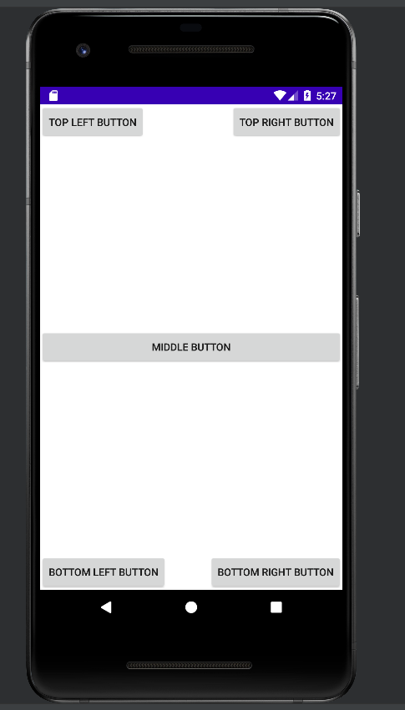

****************************End of the Assignment****************************

ASSIGNMENT NO 7

Name: Hrutu Hemant Surve Class: TY-01 CSE

PRN: 1921321242014 Faculty: Priyanka Avhad Ma`am

_____________________________________________________________________________

AIM : Implementation Implicit Intent using Action Data Pair and also send data from One Activity to Other using Explicit Intent

EXPLICIT INTENT:

XML CODE OF ACTIVITY MAIN:

<?xml version="1.0" encoding="utf-8"?>  
<androidx.constraintlayout.widget.ConstraintLayout xmlns:android="http://schemas.android.com/apk/res/android"  
 xmlns:app="http://schemas.android.com/apk/res-auto"  
 xmlns:tools="http://schemas.android.com/tools"  
 android:layout_width="match_parent"  
 android:layout_height="match_parent"  
 tools:context=".MainActivity">  
  
 <Button  
 android:id="@+id/button"  
 android:layout_width="108dp"  
 android:layout_height="93dp"  
 android:text="Next"  
 app:layout_constraintBottom_toBottomOf="parent"  
 app:layout_constraintEnd_toEndOf="parent"  
 app:layout_constraintHorizontal_bias="0.452"  
 app:layout_constraintStart_toStartOf="parent"  
 app:layout_constraintTop_toTopOf="parent"  
 app:layout_constraintVertical_bias="0.379" />  
</androidx.constraintlayout.widget.ConstraintLayout>

XML OUTPUT OF ACTIVITY MAIN:

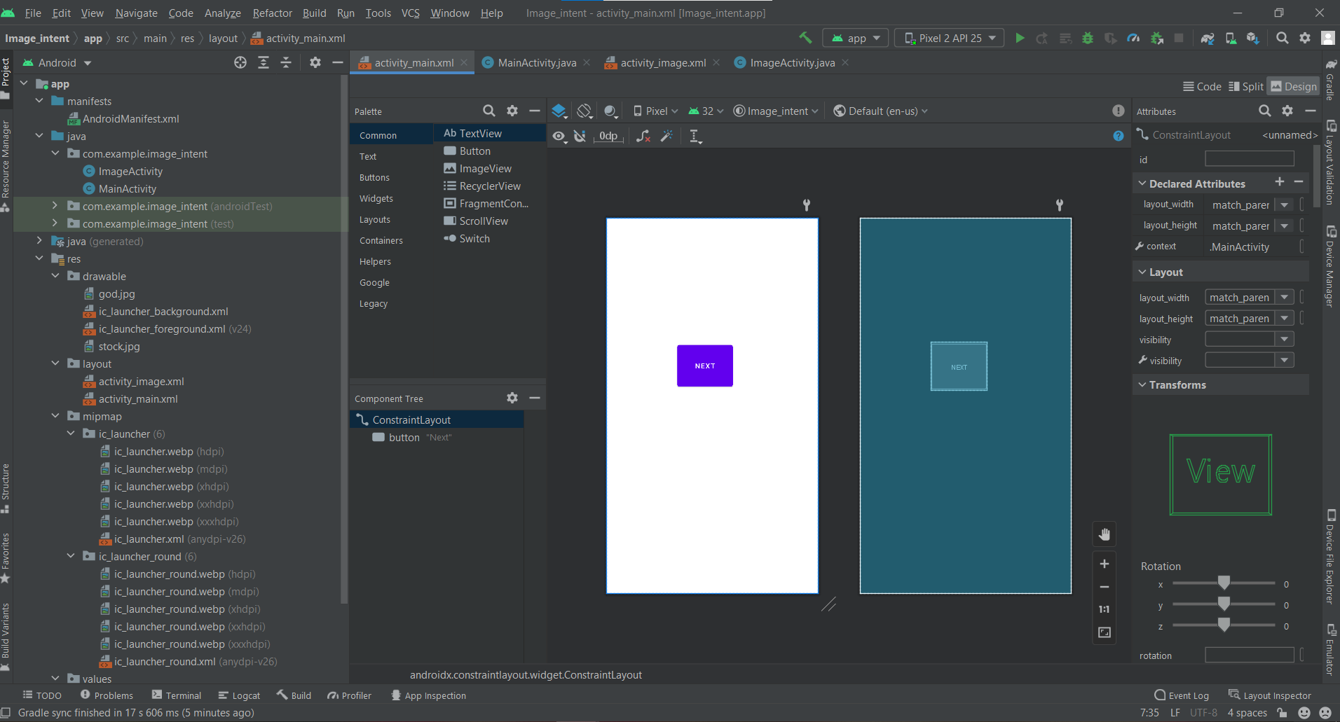

JAVA CODE OF ACTIVITY MAIN:

package com.example.image_intent;  
  
import androidx.appcompat.app.AppCompatActivity;  
  
import android.content.Intent;  
import android.os.Bundle;  
import android.view.View;  
import android.widget.Button;  
  
public class MainActivity extends AppCompatActivity {  
 Button b1;  
 @Override  
 protected void onCreate(Bundle savedInstanceState) {  
 super.onCreate(savedInstanceState);  
 setContentView(R.layout.*activity_main*);  
 b1=(Button)findViewById(R.id.*button*);  
 b1.setOnClickListener(new View.OnClickListener() {  
 @Override  
 public void onClick(View view) {  
 Intent i = new Intent(MainActivity.this,ImageActivity.class);  
 startActivity(i);  
 }  
 });  
 }  
}

XML CODE OF IMAGE ACTIVITY :

<?xml version="1.0" encoding="utf-8"?>  
<androidx.constraintlayout.widget.ConstraintLayout xmlns:android="http://schemas.android.com/apk/res/android"  
 xmlns:app="http://schemas.android.com/apk/res-auto"  
 xmlns:tools="http://schemas.android.com/tools"  
 android:layout_width="match_parent"  
 android:layout_height="match_parent"  
 tools:context=".ImageActivity">  
  
 <ImageView  
 android:id="@+id/imageView"  
 android:layout_width="wrap_content"  
 android:layout_height="wrap_content"  
 app:layout_constraintStart_toStartOf="parent"  
 app:layout_constraintTop_toTopOf="parent"  
 app:srcCompat="@drawable/stock" />  
</androidx.constraintlayout.widget.ConstraintLayout>

XML OUTPUT OF IMAGE ACTIVITY :

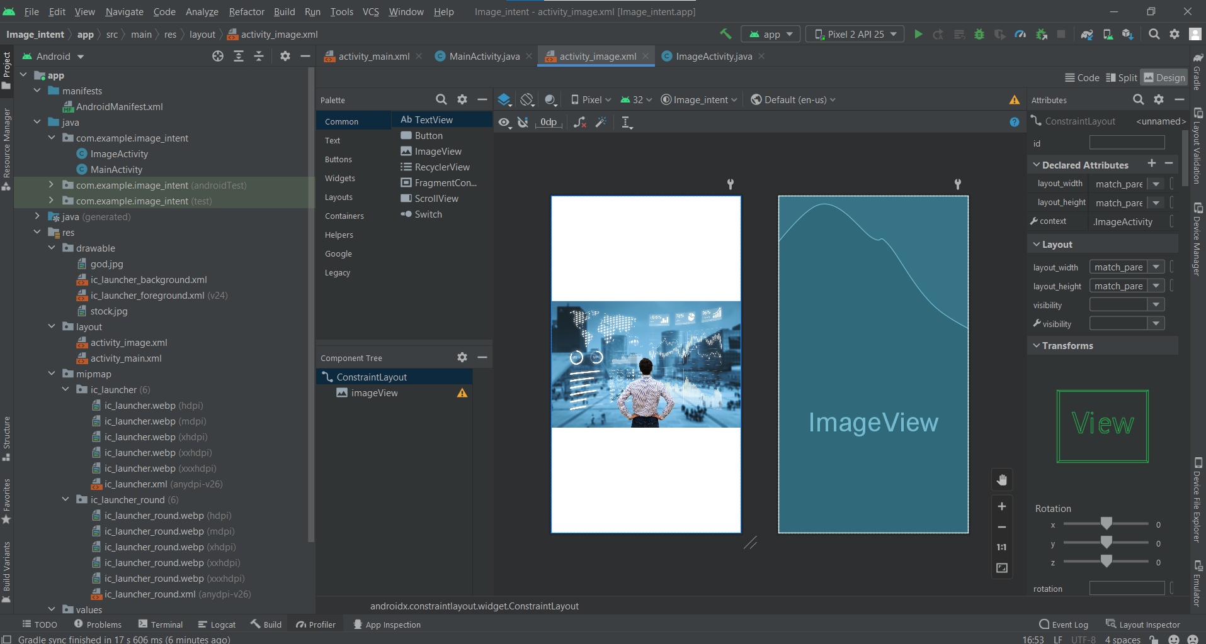

JAVA CODE OF IMAGE ACTIVITY:

package com.example.image_intent;  
  
import androidx.appcompat.app.AppCompatActivity;  
  
import android.os.Bundle;  
  
public class ImageActivity extends AppCompatActivity {  
  
 @Override  
 protected void onCreate(Bundle savedInstanceState) {  
 super.onCreate(savedInstanceState);  
 setContentView(R.layout.*activity_image*);  
 }  
}

OUTPUT :

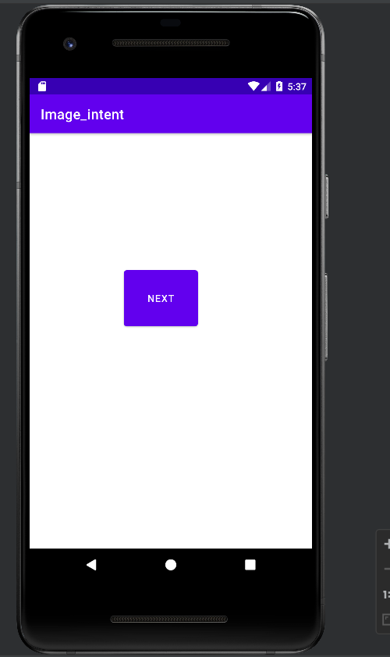

IMPLICIT INTENT:

XML CODE :

<?xml version="1.0" encoding="utf-8"?>  
<androidx.constraintlayout.widget.ConstraintLayout xmlns:android="http://schemas.android.com/apk/res/android"  
 xmlns:app="http://schemas.android.com/apk/res-auto"  
 xmlns:tools="http://schemas.android.com/tools"  
 android:layout_width="match_parent"  
 android:layout_height="match_parent"  
 tools:context=".MainActivity">  
  
 <Button  
 android:id="@+id/button2"  
 android:layout_width="wrap_content"  
 android:layout_height="wrap_content"  
 android:text="Implicit Intent"  
 app:layout_constraintBottom_toBottomOf="parent"  
 app:layout_constraintEnd_toEndOf="parent"  
 app:layout_constraintHorizontal_bias="0.416"  
 app:layout_constraintStart_toStartOf="parent"  
 app:layout_constraintTop_toTopOf="parent"  
 app:layout_constraintVertical_bias="0.325" />  
  
 <Button  
 android:id="@+id/button3"  
 android:layout_width="wrap_content"  
 android:layout_height="wrap_content"  
 android:text="phone number"  
 app:layout_constraintBottom_toBottomOf="parent"  
 app:layout_constraintEnd_toEndOf="parent"  
 app:layout_constraintHorizontal_bias="0.406"  
 app:layout_constraintStart_toStartOf="parent"  
 app:layout_constraintTop_toTopOf="parent"  
 app:layout_constraintVertical_bias="0.424" />  
  
 <Button  
 android:id="@+id/button"  
 android:layout_width="wrap_content"  
 android:layout_height="wrap_content"  
 android:text="Next"  
 app:layout_constraintBottom_toBottomOf="parent"  
 app:layout_constraintEnd_toEndOf="parent"  
 app:layout_constraintHorizontal_bias="0.321"  
 app:layout_constraintStart_toStartOf="parent"  
 app:layout_constraintTop_toTopOf="parent"  
 app:layout_constraintVertical_bias="0.241" />  
</androidx.constraintlayout.widget.ConstraintLayout>

XML OUTPUT :

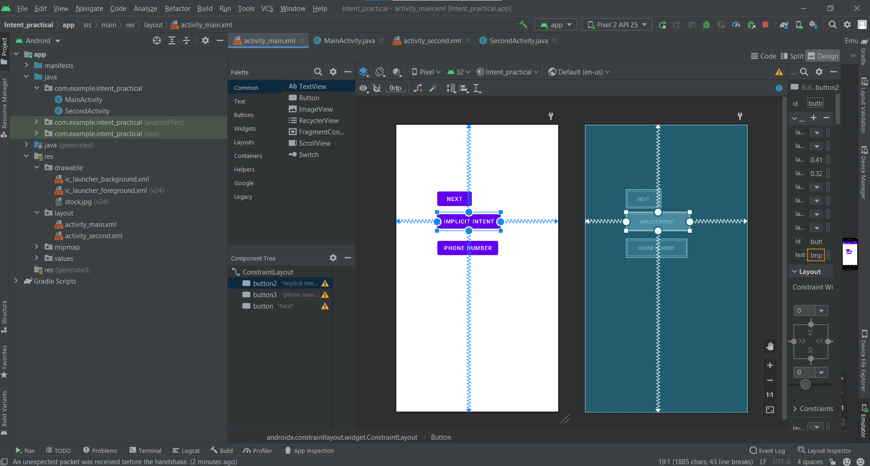

JAVA CODE :

package com.example.intent_practical;  
  
import androidx.appcompat.app.AppCompatActivity;  
  
import android.content.Intent;  
import android.net.Uri;  
import android.os.Bundle;  
import android.view.View;  
import android.widget.Button;  
  
public class MainActivity extends AppCompatActivity {  
 Button b1,b2,b3;  
 @Override  
 protected void onCreate(Bundle savedInstanceState) {  
  
 super.onCreate(savedInstanceState);  
 setContentView(R.layout.*activity_main*);  
 b1=(Button)findViewById(R.id.*button*);  
 b1.setOnClickListener(new View.OnClickListener() {  
 @Override  
 public void onClick(View view) {  
 Intent i = new Intent(MainActivity.this,SecondActivity.class);  
 startActivity(i);  
  
  
 }  
 });  
 b2=(Button)findViewById(R.id.*button2*);  
 b2.setOnClickListener(new View.OnClickListener() {  
 @Override  
 public void onClick(View view) {  
 Intent i1 = new Intent(Intent.*ACTION_VIEW*);  
 i1.setData(Uri.*parse*("https://www.geeksforgeeks.org/"));  
 startActivity(i1);  
 }  
 });  
 b3=(Button)findViewById(R.id.*button3*);  
 b3.setOnClickListener(new View.OnClickListener() {  
 @Override  
 public void onClick(View view) {  
 Intent i2 = new Intent(Intent.*ACTION_DIAL*);  
 i2.setData(Uri.*parse*("tel:+91 7387775050"));  
 startActivity(i2);  
  
 }  
 });  
 }  
}

OUTPUT :

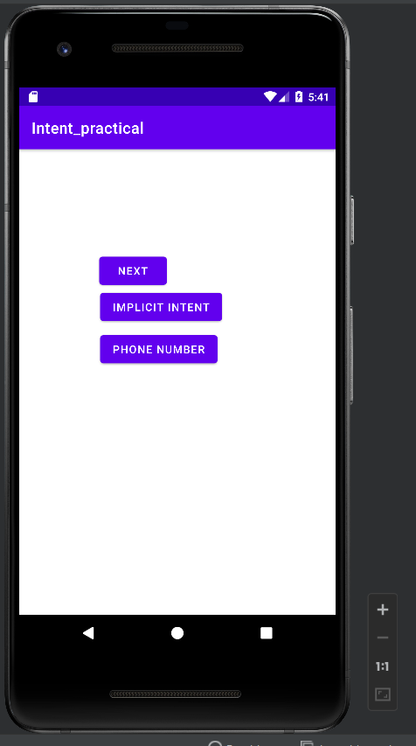

ASSIGNMENT NO 8

Name: Hrutu Hemant Surve Class: TY-01 CSE

PRN: 1921321242014 Faculty: Priyanka Avhad Ma`am

_____________________________________________________________________________

AIM : Build Km – meter Conversion App

XML CODE :

<?xml version="1.0" encoding="utf-8"?>  
<androidx.constraintlayout.widget.ConstraintLayout xmlns:android="http://schemas.android.com/apk/res/android"  
 xmlns:app="http://schemas.android.com/apk/res-auto"  
 xmlns:tools="http://schemas.android.com/tools"  
 android:layout_width="match_parent"  
 android:layout_height="match_parent"  
 tools:context=".MainActivity">  
  
 <Button  
 android:id="@+id/button"  
 android:layout_width="wrap_content"  
 android:layout_height="wrap_content"  
 android:text="KILOMETER TO METER"  
 app:layout_constraintBottom_toBottomOf="parent"  
 app:layout_constraintEnd_toEndOf="parent"  
 app:layout_constraintHorizontal_bias="0.507"  
 app:layout_constraintStart_toStartOf="parent"  
 app:layout_constraintTop_toTopOf="parent"  
 app:layout_constraintVertical_bias="0.333" />  
  
 <Button  
 android:id="@+id/button2"  
 android:layout_width="wrap_content"  
 android:layout_height="wrap_content"  
 android:text="METER TO KILOMETER"  
 app:layout_constraintBottom_toBottomOf="parent"  
 app:layout_constraintEnd_toEndOf="parent"  
 app:layout_constraintHorizontal_bias="0.509"  
 app:layout_constraintStart_toStartOf="parent"  
 app:layout_constraintTop_toTopOf="parent"  
 app:layout_constraintVertical_bias="0.427" />  
  
 <TextView  
 android:id="@+id/textView"  
 android:layout_width="292dp"  
 android:layout_height="78dp"  
 android:hint="ANSWER"  
 android:textSize="24sp"  
 app:layout_constraintBottom_toBottomOf="parent"  
 app:layout_constraintEnd_toEndOf="parent"  
 app:layout_constraintHorizontal_bias="0.451"  
 app:layout_constraintStart_toStartOf="parent"  
 app:layout_constraintTop_toTopOf="parent"  
 app:layout_constraintVertical_bias="0.606" />  
  
 <EditText  
 android:id="@+id/editTextTextPersonName"  
 android:layout_width="217dp"  
 android:layout_height="69dp"  
 android:ems="10"  
 android:hint="ENTER VALUE"  
 android:inputType="textPersonName"  
 app:layout_constraintBottom_toBottomOf="parent"  
 app:layout_constraintEnd_toEndOf="parent"  
 app:layout_constraintHorizontal_bias="0.551"  
 app:layout_constraintStart_toStartOf="parent"  
 app:layout_constraintTop_toTopOf="parent"  
 app:layout_constraintVertical_bias="0.196" />  
</androidx.constraintlayout.widget.ConstraintLayout>

XML OUTPUT :

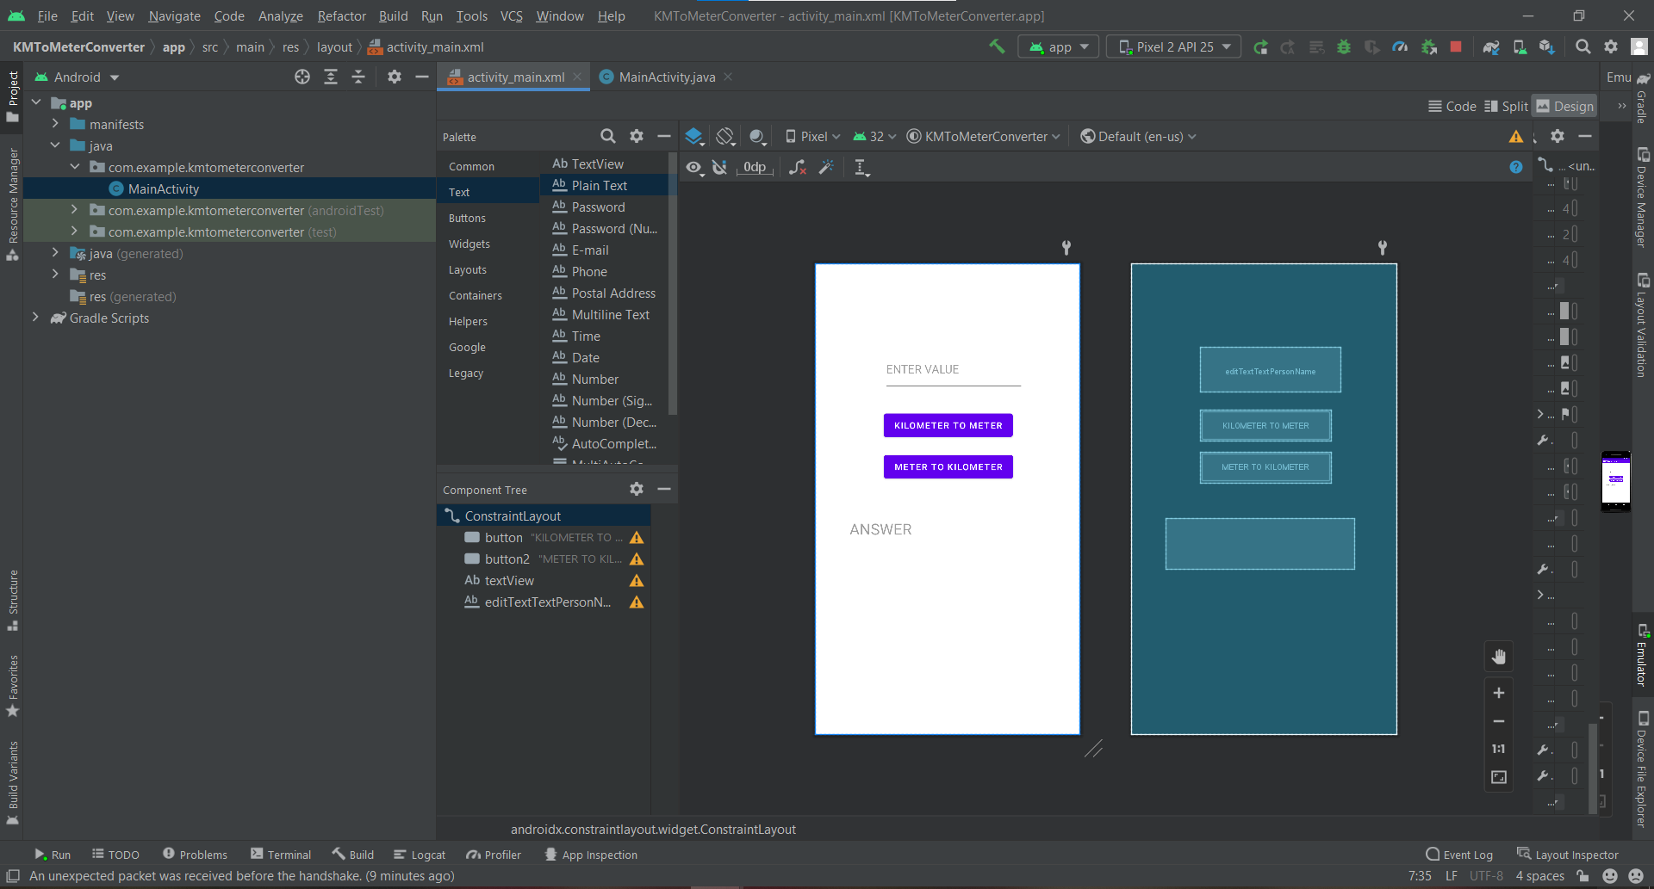

JAVA CODE :

package com.example.kmtometerconverter;  
  
import androidx.appcompat.app.AppCompatActivity;  
  
import android.os.Bundle;  
import android.view.View;  
import android.widget.Button;  
import android.widget.EditText;  
import android.widget.TextView;  
  
public class MainActivity extends AppCompatActivity {  
 Button KMTOM,MTOKM;  
 TextView Result;  
 EditText Value;  
 @Override  
 protected void onCreate(Bundle savedInstanceState) {  
 super.onCreate(savedInstanceState);  
 setContentView(R.layout.*activity_main*);  
 Value=(EditText)findViewById(R.id.*editTextTextPersonName*);  
 KMTOM=(Button)findViewById(R.id.*button*);  
 MTOKM=(Button)findViewById(R.id.*button2*);  
 Result=(TextView)findViewById(R.id.*textView*);  
 KMTOM.setOnClickListener(new View.OnClickListener() {  
 @Override  
 public void onClick(View view) {  
 float input=Float.*parseFloat*(Value.getText().toString());  
 float answer=input*1000;  
 Result.setText(" "+answer+"METER");  
 }  
 });  
 MTOKM.setOnClickListener(new View.OnClickListener() {  
 @Override  
 public void onClick(View view) {  
 float input=Float.*parseFloat*(Value.getText().toString());  
 float answer=input/1000;  
 Result.setText(" "+answer+"KILOMETER");  
 }  
 });  
 }  
}

OUTPUT :

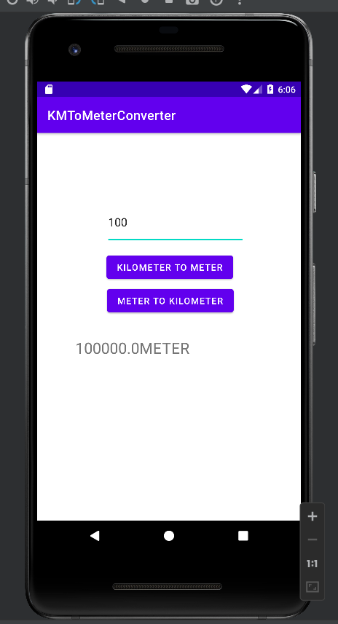

****************************End of the Assignment****************************

ASSIGNMENT NO 9

Name: Hrutu Hemant Surve Class: TY-01 CSE

PRN: 1921321242014 Faculty: Priyanka Avhad Ma`am

Aim : Build Android Application using SQLite Database

XML code :

<?xml version="1.0" encoding="utf-8"?>  
<androidx.constraintlayout.widget.ConstraintLayout xmlns:android="http://schemas.android.com/apk/res/android"  
 xmlns:app="http://schemas.android.com/apk/res-auto"  
 xmlns:tools="http://schemas.android.com/tools"  
 android:layout_width="match_parent"  
 android:layout_height="match_parent"  
 tools:context=".MainActivity">  
  
 <EditText  
 android:id="@+id/editTextTextPersonName"  
 android:layout_width="wrap_content"  
 android:layout_height="wrap_content"  
 android:ems="10"  
 android:hint="ROLL.NO"  
 android:inputType="textPersonName"  
 android:minHeight="48dp"  
 app:layout_constraintBottom_toBottomOf="parent"  
 app:layout_constraintEnd_toEndOf="parent"  
 app:layout_constraintHorizontal_bias="0.497"  
 app:layout_constraintStart_toStartOf="parent"  
 app:layout_constraintTop_toTopOf="parent"  
 app:layout_constraintVertical_bias="0.154"  
 android:autofillHints="" />  
  
 <EditText  
 android:id="@+id/editTextTextPersonName2"  
 android:layout_width="wrap_content"  
 android:layout_height="wrap_content"  
 android:ems="10"  
 android:hint="NAME"  
 android:inputType="textPersonName"  
 android:minHeight="48dp"  
 app:layout_constraintBottom_toBottomOf="parent"  
 app:layout_constraintEnd_toEndOf="parent"  
 app:layout_constraintHorizontal_bias="0.497"  
 app:layout_constraintStart_toStartOf="parent"  
 app:layout_constraintTop_toTopOf="parent"  
 app:layout_constraintVertical_bias="0.313"  
 android:autofillHints="" />  
  
 <Button  
 android:id="@+id/button"  
 android:layout_width="wrap_content"  
 android:layout_height="wrap_content"  
 android:onClick="insertdata"  
 android:text="Submit"  
 app:layout_constraintBottom_toBottomOf="parent"  
 app:layout_constraintEnd_toEndOf="parent"  
 app:layout_constraintStart_toStartOf="parent"  
 app:layout_constraintTop_toTopOf="parent" />  
  
</androidx.constraintlayout.widget.ConstraintLayout>

XML output :

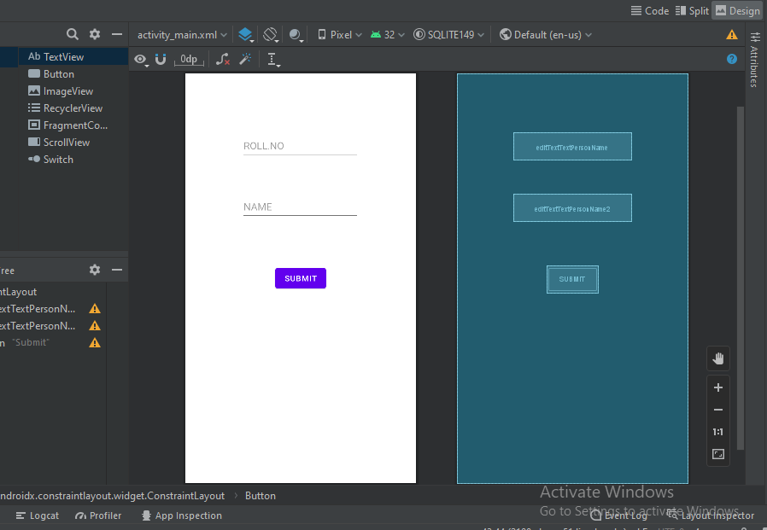

JAVA code :

package com.example.sqlite149;  
  
import androidx.appcompat.app.AppCompatActivity;  
  
import android.os.Bundle;  
import android.view.View;  
import android.widget.Button;  
import android.widget.EditText;  
import android.widget.Toast;  
  
public class MainActivity extends AppCompatActivity {  
 EditText roll,name;  
 Button b1;  
  
 DatabaseHandler dbh;  
 @Override  
 protected void onCreate(Bundle savedInstanceState) {  
 super.onCreate(savedInstanceState);  
 setContentView(R.layout.*activity_main*);  
 roll=(EditText) findViewById(R.id.*editTextTextPersonName*);  
 name=(EditText) findViewById(R.id.*editTextTextPersonName2*);  
 b1=(Button) findViewById(R.id.*button*);  
  
  
 dbh = new DatabaseHandler(MainActivity.this);  
 }  
  
  
 public void insertdata(View view) {  
  
  
 int rno= Integer.*parseInt*(roll.getText().toString());  
 String n = name.getText().toString();  
 dbh.opendb();  
 dbh.insertvalues(rno,n);  
 Toast.*makeText*(this,"Data inserted", Toast.*LENGTH_SHORT*).show();  
 dbh.closedb();  
 }  
  
}

databasehelper File code:

package com.example.sqlite149;  
  
import android.content.ContentValues;  
import android.content.Context;  
import android.database.sqlite.SQLiteDatabase;  
import android.database.sqlite.SQLiteOpenHelper;  
  
import androidx.annotation.Nullable;  
  
public class DatabaseHandler extends SQLiteOpenHelper {  
 private static final String *dname*="Student Database";  
 SQLiteDatabase sqdb;  
  
 public DatabaseHandler(@Nullable Context context) {  
 super(context, *dname*, null, 1);  
 }  
  
 @Override  
 public void onCreate(SQLiteDatabase db) {  
 String query= "create table studdetail(rollno,name)";  
 db.execSQL(query);  
 }  
  
 @Override  
 public void onUpgrade(SQLiteDatabase db, int oldVersion, int newVersion) {  
  
 }  
 public void opendb()  
 {  
 sqdb= getWritableDatabase();  
 }  
 public void closedb()  
 {  
 sqdb.close();  
 }  
  
  
  
 public void insertvalues(int r,String n )  
 {  
 ContentValues cv= new ContentValues();  
 cv.put("rollno",r);  
 cv.put("name",n);  
 sqdb.insert("studdetail",null,cv);  
 }  
  
  
}

Output :

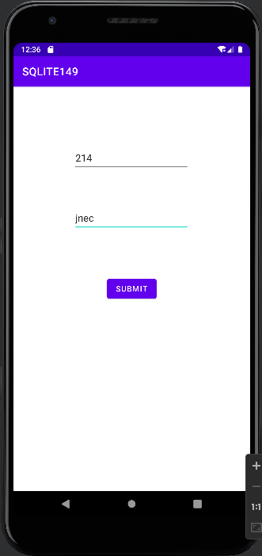

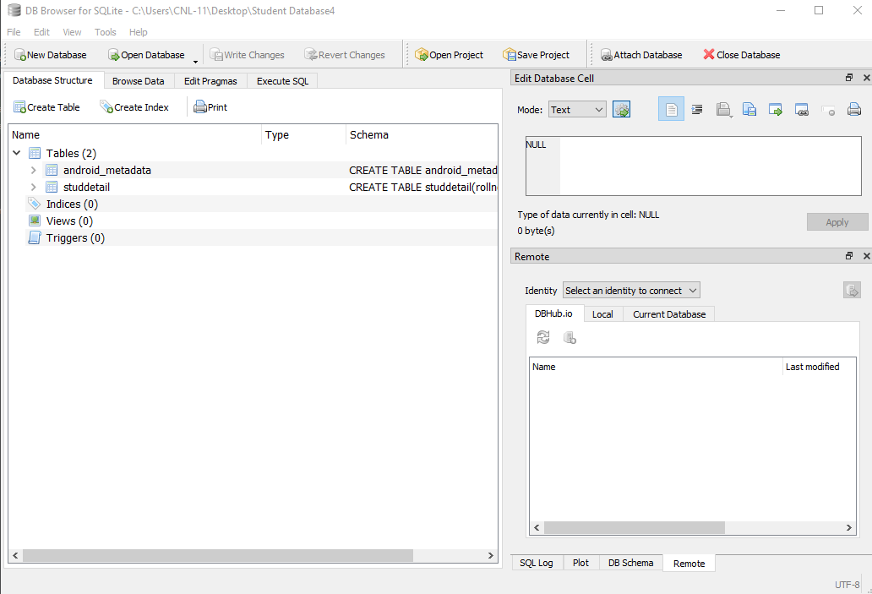

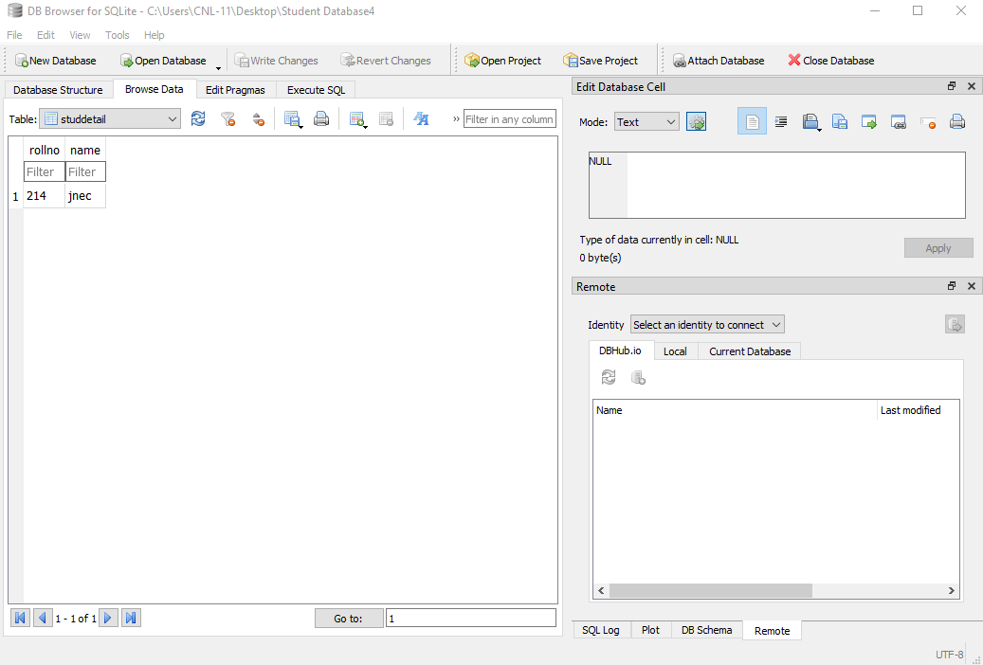

************************************End of the Assignment*********************************